**Bahria University,**

**Karachi Campus**



**LAB EXPERIMENT NO.**

**12**

**LIST OF TASKS**

|  |  |
| --- | --- |
| TASK NO | OBJECTIVE |
|  | SQL WINDOWS FUNCTIONS |
| **01** | **Rank the employees based on their sales amount** |
| **02** | **Determine the month-wise sales growth rate for each product.** |
| **03** | **Rank the customers based on their total order count in each country.** |
| **04** | **Use Right join to display those publishers where title is null.** |
| 05 | Distribute customers into deciles (10) based on their order count. |

**Submitted On:**

**06 - 06 - 2023**

**(Date: DD/MM/YYYY)**

**Task No. 1:** Rank the employees based on their sales amount.

**Solution:**

SELECT EmployeeID, SUM(UnitPrice * Quantity) AS TotalSales

FROM Orders

JOIN [Order Details] ON Orders.OrderID = [Order Details].OrderID

GROUP BY EmployeeID

ORDER BY TotalSales DESC;

**Output:**

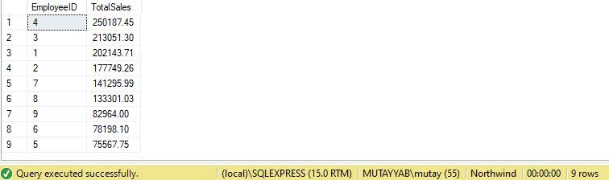

Student@sabir

**Task No. 2:** Determine the month-wise sales growth rate for each product.

**Solution:**

SELECT

p.ProductID,

p.ProductName,

DATEPART(YEAR, o.OrderDate) AS SalesYear,

DATEPART(MONTH, o.OrderDate) AS SalesMonth,

SUM(od.UnitPrice * od.Quantity) AS TotalSales,

(SUM(od.UnitPrice * od.Quantity) - LAG(SUM(od.UnitPrice * od.Quantity)) OVER (PARTITION BY p.ProductID ORDER BY DATEPART(YEAR, o.OrderDate), DATEPART(MONTH, o.OrderDate))) / LAG(SUM(od.UnitPrice * od.Quantity)) OVER (PARTITION BY p.ProductID ORDER BY DATEPART(YEAR, o.OrderDate), DATEPART(MONTH, o.OrderDate)) AS GrowthRate

FROM Orders o

JOIN [Order Details] od ON o.OrderID = od.OrderID

JOIN Products p ON od.ProductID = p.ProductID

GROUP BY p.ProductID, p.ProductName, DATEPART(YEAR, o.OrderDate), DATEPART(MONTH, o.OrderDate)

ORDER BY p.ProductName, DATEPART(YEAR, o.OrderDate), DATEPART(MONTH, o.OrderDate);

**Output:**

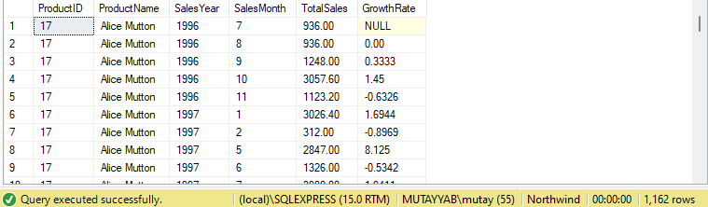

Student@sabir

**Task No. 3:** Rank the customers based on their total order count in each country.

**Solution:**

SELECT

c.CustomerID,

c.Country,

COUNT(DISTINCT o.OrderID) AS OrderCount

FROM Customers c

JOIN Orders o ON c.CustomerID = o.CustomerID

GROUP BY c.CustomerID, c.Country

ORDER BY c.Country, OrderCount DESC;

**Output:**

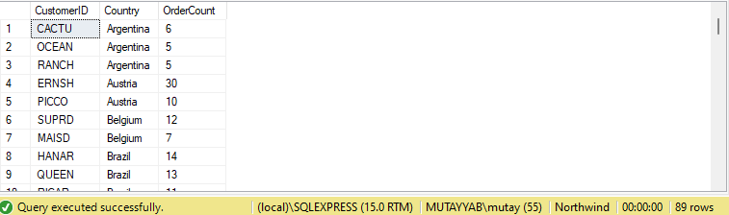

Student@sabir

**Task No. 4:** Distribute customers into deciles (10) based on their order count.

**Solution:**

WITH CustomerOrderCounts AS (

SELECT

c.CustomerID,

COUNT(DISTINCT o.OrderID) AS OrderCount,

NTILE(10) OVER (ORDER BY COUNT(DISTINCT o.OrderID) DESC) AS Decile

FROM Customers c

JOIN Orders o ON c.CustomerID = o.CustomerID

GROUP BY c.CustomerID

)

SELECT CustomerID, OrderCount, Decile

FROM CustomerOrderCounts

ORDER BY Decile, OrderCount DESC;

**Output:**

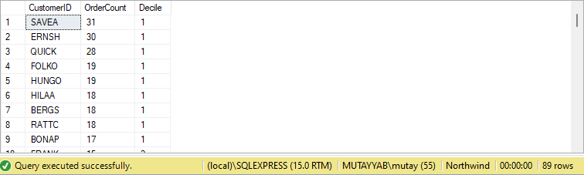

Student@sabir

**Task No. 5:** Divide employees into three groups based on their sales performance.

**Solution:**

WITH EmployeeSales AS (

SELECT

EmployeeID,

SUM(UnitPrice * Quantity) AS TotalSales,

NTILE(3) OVER (ORDER BY SUM(UnitPrice * Quantity) DESC) AS SalesGroup

FROM Orders

JOIN [Order Details] ON Orders.OrderID = [Order Details].OrderID

GROUP BY EmployeeID

)

SELECT EmployeeID, TotalSales, SalesGroup

FROM EmployeeSales

ORDER BY SalesGroup, TotalSales DESC;

**Output:** 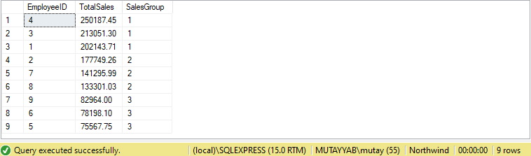

Student@sabir